[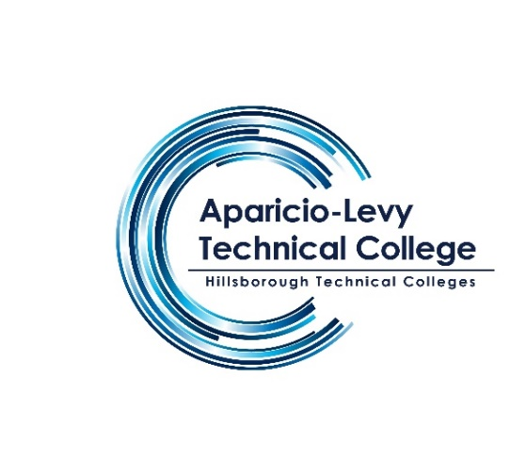](http://www.hillsboroughschools.org/altc)

**Aparicio-Levy Technical College**

**10119 East Ellicott Street**

**Tampa, FL 33610**

**(813) 740 – 4884 ext. 2**

**Mr. Rafael Corsi / School Counselor**

Rafael.corsibracetti@hcps.net

**Applied Cybersecurity Program**

|  |  |
| --- | --- |
| Cost: | $ 4,559.00  *(subject to change)* |
| Length: | 750 hours (7-8 months)  Monday – Friday  8:00am – 2:00pm |
| Next Class Start Dates: | September 2026 |
| Admissions Requirements: | * High school diploma or GED * Photo ID/proof of age |
| Financial Aid: | Program eligible for FAFSA/PELL. Financial Aid available for eligible students. |

[](https://www.hillsboroughschools.org/)[](https://council.org/) 

The Applied Cybersecurity program is designed to prepare you for employment in the fast-growing field of Cybersecurity.

The content includes but is not limited to foundational knowledge and skills in computer and network security, security vulnerabilities, attack mechanisms and techniques, intrusion detection and prevention, cryptographic systems, system hardening, risk identification, incidence response, penetration testing, key management, access control, and recovery. Specialized courses focus on database security, planning and analysis, software, and web security.